Certificate
Department of Computer Science and Engineering

This is to certify that this Practical Record contains the bona fide practical work carried out by Mr./Ms. ______________________________________________, bearing PRN. _____________________, of Batch _________, Semester ______, Section _________, during the Academic Year __________________.

Date: _____________

Name of Course Teacher: _________________________________________

Signature of Course Teacher: ______________________________________

Name of Student: ________________________ PRN: _________________
Batch: ______________ Semester: ____________ Section: ______________
Index
Practical No. | Aim | Performance Date | Submission Date | Remarks
1 | Demonstrate inline, internal, and external JavaScript; use console methods; create a webpage showing user info and a welcome message.
2 | Use var, let, const, and demonstrate basic features like template literals and destructuring; build a billing calculator with user input.
3 | Implement control structures and form validation; create a grading system based on user-entered marks.
4 | Use function types, scope, and closures; apply try-catch; build a palindrome checker.
5 | Apply array methods and object handling; create a cart total calculator with discount logic.
6 | Use string functions and regex for email validation, data extraction, and text analysis.
7 | Perform DOM traversal and updates; develop a to-do list app with add, edit, and delete features.
8 | Access and validate form fields using events; design a gym admission form with live input checks.
9 | Implement localStorage and sessionStorage to save user preferences like theme settings.
10 | Load and display JSON data using fetch() and jQuery $.getJSON(); render results dynamically in a table.
VA 11 | Use JavaScript timers (setTimeout(), setInterval()) and ES6 modules (import/export) to build a dynamic countdown or class scheduler with real-time updates and responsive layout.
VA 12 | Build an interactive real-time web app using JavaScript and jQuery with DOM, events, storage, and AJAX integration.
EXPERIMENT NO : 1

- Title : Demonstrate inline, internal and external JavaScript; use console methods; create a webpage showing user info and a welcome message.

- Software/Tools Required : Visual Studio Code, Google Chrome, HTML5, CSS3, and JavaScript.

- Theory : JavaScript is a scripting language used to make web pages interactive and dynamic. It can be added to an HTML document in three different ways :
- Inline JavaScript:
Inline JavaScript is written directly inside an HTML element using event attributes such as onclick. In this experiment, it was used to perform an action directly when the user interacted with a webpage element.

- Internal JavaScript:
Internal JavaScript is written inside the <script> tag within the same HTML file. In this experiment, JavaScript functions were defined internally and called when specific user interactions occurred on the webpage.

- External JavaScript:
External JavaScript is written in a separate .js file and connected to the HTML document using the <script src= “…”></script> tag. In this experiment, external JavaScript was used to keep the scripting code separate from the HTML structure.

- Code :
- <!DOCTYPE html>
- <html lang="en">
- <head>
- <meta charset="UTF-8">
- <meta name="viewport" content="width=device-width, initial-scale=1.0">
- <title>JavaScript Demonstration | Lab Experiment</title>

- <style>
- :root {
- --bg-color: #f8fafc;
- --card-bg: #ffffff;
- --primary: #2563eb;
- --primary-hover: #1d4ed8;
- --text-main: #0f172a;
- --text-muted: #475569;
- --border: #e2e8f0;
- --shadow: 0 4px 6px -1px rgb(0 0 0 / 0.1), 0 2px 4px -2px rgb(0 0 0 / 0.1);
- }

- * {
- box-sizing: border-box;
- margin: 0;
- padding: 0;
- }

- body {
- font-family: 'Segoe UI', Tahoma, Geneva, Verdana, sans-serif;
- background-color: var(--bg-color);
- color: var(--text-main);
- line-height: 1.6;
- padding: 40px 20px;
- display: flex;
- justify-content: center;
- align-items: center;
- min-height: 100vh;
- }

- .dashboard {
- background: var(--card-bg);
- padding: 40px;
- border-radius: 16px;
- width: 100%;
- max-width: 650px;
- box-shadow: var(--shadow);
- border: 1px solid var(--border);
- }

- header {
- text-align: center;
- margin-bottom: 30px;
- border-bottom: 2px solid var(--border);
- padding-bottom: 20px;
- }

- h1 {
- color: var(--primary);
- font-size: 28px;
- font-weight: 700;
- margin-bottom: 8px;
- }

- .welcome-box {
- font-size: 16px;
- color: var(--text-muted);
- font-style: italic;
- min-height: 24px;
- }

- .section-title {
- font-size: 18px;
- color: var(--text-main);
- margin-bottom: 15px;
- font-weight: 600;
- display: flex;
- align-items: center;
- gap: 8px;
- }

- .info-grid {
- display: grid;
- grid-template-columns: repeat(2, 1fr);
- gap: 15px;
- background: #f1f5f9;
- padding: 20px;
- border-radius: 12px;
- margin-bottom: 30px;
- }

- .info-item span {
- display: block;
- font-size: 12px;
- text-transform: uppercase;
- color: var(--text-muted);
- font-weight: 600;
- letter-spacing: 0.5px;
- }

- .info-item p {
- font-size: 16px;
- font-weight: 600;
- color: var(--text-main);
- }

- .demo-area {
- display: flex;
- flex-direction: column;
- gap: 15px;
- margin-bottom: 35px;
- }

- .btn-card {
- display: flex;
- justify-content: space-between;
- align-items: center;
- padding: 15px 20px;
- background: var(--card-bg);
- border: 1px solid var(--border);
- border-radius: 10px;
- transition: transform 0.2s, box-shadow 0.2s;
- }

- .btn-card:hover {
- transform: translateY(-2px);
- box-shadow: 0 4px 12px rgb(0 0 0 / 0.05);
- }

- .btn-desc {
- text-align: left;
- }

- .btn-desc h4 {
- font-size: 15px;
- color: var(--text-main);
- }

- .btn-desc p {
- font-size: 12px;
- color: var(--text-muted);
- }

- button {
- background-color: var(--primary);
- color: white;
- border: none;
- padding: 10px 18px;
- font-size: 14px;
- font-weight: 500;
- border-radius: 6px;
- cursor: pointer;
- transition: background-color 0.2s;
- white-space: nowrap;
- }

- button:hover {
- background-color: var(--primary-hover);
- }

- footer {
- text-align: center;
- border-top: 1px solid var(--border);
- padding-top: 20px;
- font-size: 13px;
- color: var(--text-muted);
- }

- footer strong {
- color: var(--text-main);
- }
- </style>

- <!-- Internal JavaScript -->
- <script>
- function showWelcome() {
- // Target the welcome container safely
- const welcomeElement = document.getElementById("welcome");
- if (welcomeElement) {
- welcomeElement.innerHTML = "Welcome to the JavaScript Demonstration Webpage!";
- }

- // Demonstrate diverse Console Methods
- console.log("Welcome message dynamically injected via Internal JS.");
- console.info("Internal JavaScript block executed successfully on body load.");
- console.warn("Console demonstration initialization completed.");
- }
- </script>
- </head>
- <body onload="showWelcome()">

- <div class="dashboard">
- <header>
- <h1>JS Execution Environments</h1>
- <p id="welcome" class="welcome-box"></p>
- </header>

- <main>
- <h3 class="section-title">User Metadata</h3>
- <div class="info-grid">
- <div class="info-item">
- <span>Developer Name</span>
- <p>Arya Khandekar</p>
- </div>
- <div class="info-item">
- <span>Permanent Reg. No (PRN)</span>
- <p>24070521219</p>
- </div>
- </div>

- <h3 class="section-title">Execution Controls</h3>
- <div class="demo-area">
- <!-- Inline JavaScript Block -->
- <div class="btn-card">
- <div class="btn-desc">
- <h4>Inline Execution</h4>
- <p>Triggers script directly inside the HTML tag attributes.</p>
- </div>
- <button onclick="console.log('Inline button clicked.'); alert('Hello Arya Khandekar! This is Inline JavaScript.');">
- Run Inline
- </button>
- </div>

- <!-- External JavaScript Block -->
- <div class="btn-card">
- <div class="btn-desc">
- <h4>External Execution</h4>
- <p>Calls decoupled functions stored inside an detached script file.</p>
- </div>
- <button onclick="showExternalMessage()">
- Run External
- </button>
- </div>
- </div>
- </main>

- <footer>
- <p>Webpage engineered for academic evaluation by <strong>Arya Khandekar</strong> (PRN: 24070521219)</p>
- </footer>
- </div>

- <!-- External JavaScript File -->
- <script src="script.js"></script>

- </body>
- </html>

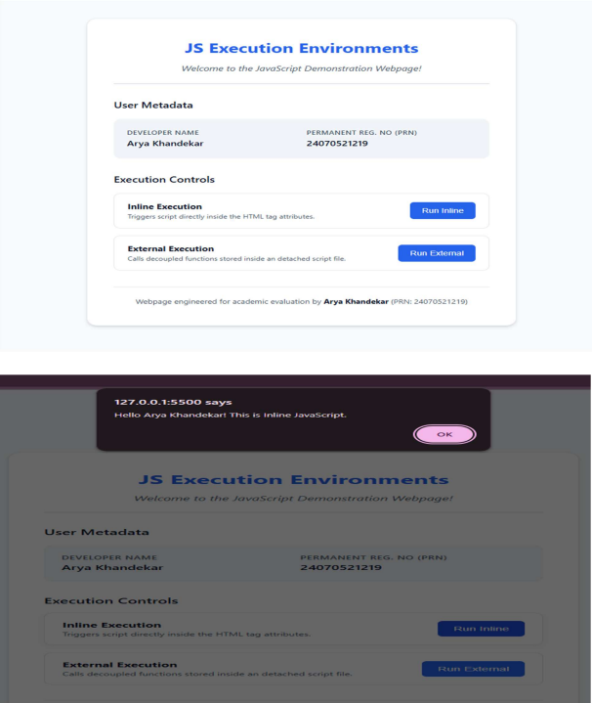
5. OUTPUT :

6. CONCLUSION :
Thus, a webpage was successfully created using HTML, CSS and JavaScript.
The three methods of integrating JavaScript inline, internal and external were
successfully implemented and demonstrated through different interactive
features on the webpage.

CASE STUDY : 1

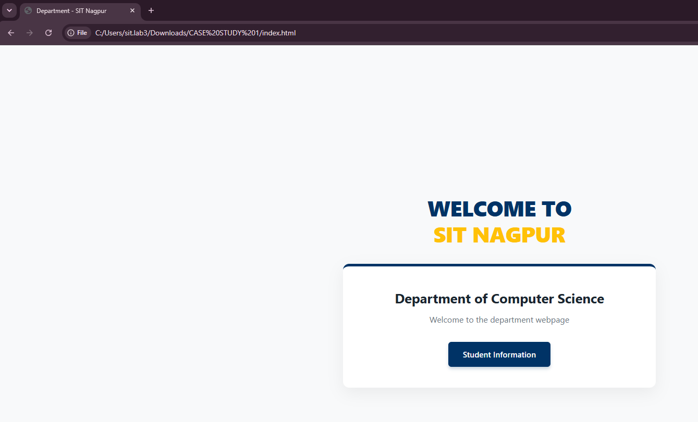

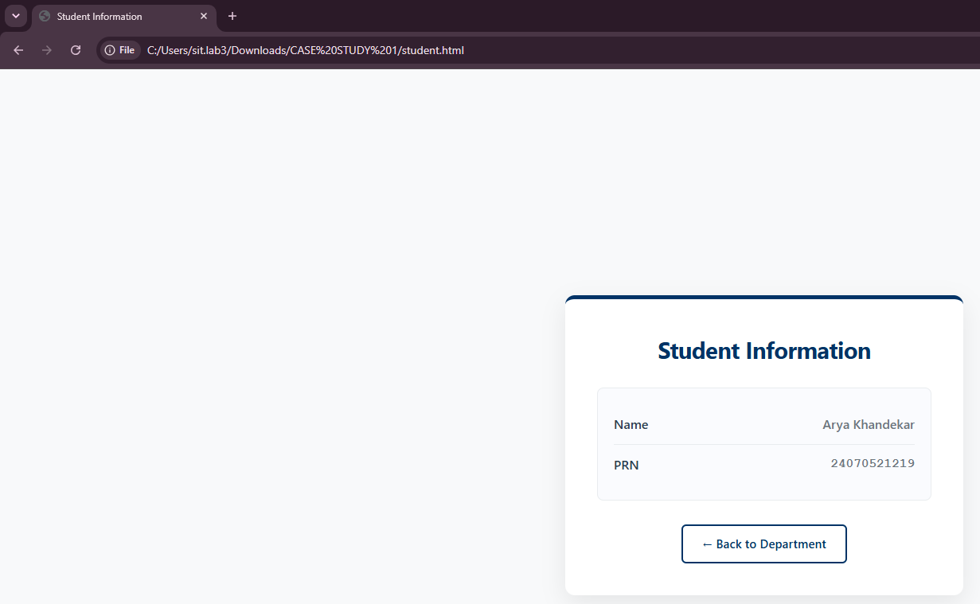

EXPERIMENT NO : 2
- AIM : Use var, let, const, and demonstrate basic features like template literals
and destructuring; build a billing calculator with user input.

- Software/Tools Required : Visual Studio Code, Google Chrome, HTML5,
CSS3, and JavaScript.

- Theory :
- JavaScript variables are used to store data or values in a program. They help us save information like numbers, text, or other data so that we can use it
later in the code.

- var is the old way of declaring variables in JavaScript. It is function-scoped,
and the value of a var variable can be changed. It can also be declared again
in the same scope.

- let is the modern way of declaring variables. It is block-scoped, which means
it can only be used inside the block { } where it is declared. Its value can be
changed, but it cannot be declared again in the same block.

- const is used to declare variables whose value should not change. It is also
block-scoped and must be given a value when it is created. Once assigned,
its value cannot be changed.

- CODE :
- <!DOCTYPE html>
- <html lang="en">
- <head>
- <meta charset="UTF-8">
- <meta name="viewport" content="width=device-width, initial-scale=1.0">
- <title>Billing Calculator Experiment</title>
- <style>
- body {
- font-family: Arial, sans-serif;
- background-color: #ffffff;
- margin: 20px;
- padding: 20px;
- }
- pre {
- white-space: pre-wrap;
- font-family: 'Courier New', Courier, monospace;
- margin-top: 20px;
- color: #000;
- }
- .developer-footer {
- margin-top: 20px;
- padding-top: 15px;
- border-top: 1px dashed #ccc;
- font-size: 14px;
- color: #555;
- line-height: 1.4;
- }
- </style>
- </head>
- <body>

- <h2>Billing Calculator</h2>
- <p>Your receipt has been generated below:</p>

- <pre id="receiptDisplay"></pre>

- <div class="developer-footer">
- <strong>Developed By:</strong><br>
- Name: Arya Khandekar<br>
- PRN: 24070521219
- </div>

- <script>
- var customerName = prompt("Enter customer name:");
- var productName = prompt("Enter product name:");
- let costPerProduct = parseFloat(prompt("Enter cost per product (₹):").replace(/,/g, ''));
- let quantity = parseInt(prompt("Enter quantity:").replace(/,/g, ''));

- const GST_RATE = 0.18;

- let totalBeforeTax = costPerProduct * quantity;
- let gstAmount = totalBeforeTax * GST_RATE;
- let finalBill = totalBeforeTax + gstAmount;

- const receiptObject = {
- custName: customerName,
- prodName: productName,
- qty: quantity,
- baseCost: totalBeforeTax,
- tax: gstAmount,
- totalPayable: finalBill
- };

- const { custName, prodName, qty, baseCost, tax, totalPayable } = receiptObject;

- const billingReceipt = `
- ========================================
- QUICKBILL MART
- ========================================
- Developer Name : ARYA KHANDEKAR
- PRN : 24070521219
- ----------------------------------------
- Customer Name : ${custName}
- Product Name : ${prodName}
- Quantity : ${qty}
- Cost per Unit : ₹${costPerProduct.toFixed(2)}
- ----------------------------------------
- Total (Base) : ₹${baseCost.toFixed(2)}
- GST (18%) : ₹${tax.toFixed(2)}
- ----------------------------------------
- FINAL BILL : ₹${totalPayable.toFixed(2)}
- ========================================
- `;

- document.getElementById("receiptDisplay").innerText = billingReceipt;
- console.log(billingReceipt);
- </script>

- </body>
- </html>

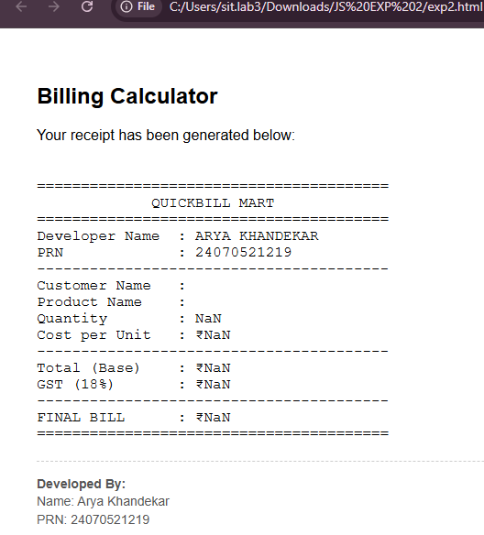
5. OUTPUT :

- CONCLUSION :
The experiment was successfully completed. I learned how to use var, let, and
const for declaring variables in JavaScript and understood their basic differences. This experiment also helped me understand the basic concepts of modern JavaScript.

CASE STUDY : 2

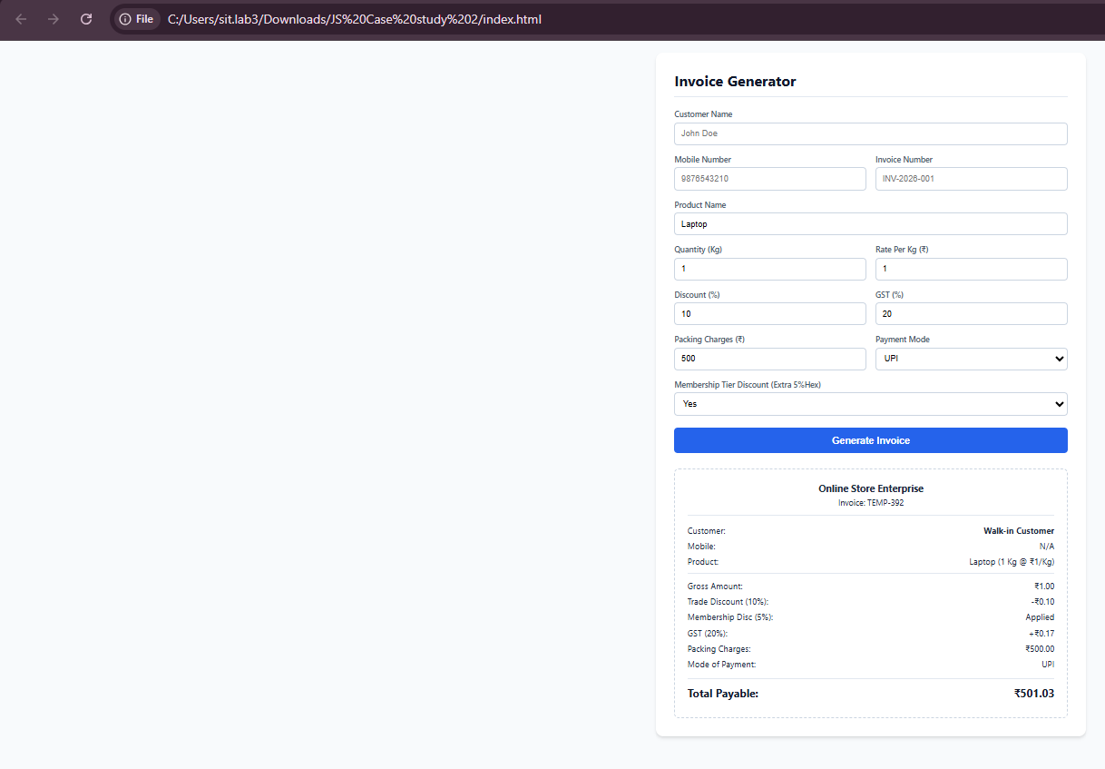

EXPERIMENT NO : 3
- AIM : Implement control structures and form validation; create a grading system based on user-entered marks.

- SOFTWARE / TOOLS USED : HTML5 , CSS3, JavaScript, Visual Studio Code (VS Code), Google Chrome / Microsoft Edge Web Browser.

- THEORY : Control structures are an essential part of JavaScript programming that allow the execution of different statements based on specific conditions. Conditional statements such as if, else if, and else are commonly used to evaluate marks and assign grades accordingly.
Form validation is used to ensure that users enter valid information before processing the data. It checks whether all required fields are filled correctly and whether the entered marks fall within the valid range (0–100). This helps prevent incorrect or incomplete data from being processed.
In this experiment, an Academic Entry Portal is developed using HTML, CSS, and JavaScript. The application accepts the student's name, PRN number, and marks for five subjects. JavaScript validates the input, calculates the total marks, percentage, and assigns an appropriate grade using conditional statements. The system displays the final result only after successful validation, making the application reliable and user-friendly.
- CODE :
- <!DOCTYPE html>
- <html lang="en">
- <head>
- <title>Academic Entry Portal</title>
- <style>
- body {
- font-family: Arial, sans-serif;
- margin: 40px;
- display: flex;
- gap: 50px;
- }
- .portal-side {
- width: 350px;
- }
- .receipt-side {
- width: 400px;
- }
- .header-title {
- font-weight: bold;
- font-size: 1.1em;
- margin-bottom: 5px;
- }
- hr {
- border: 0;
- border-top: 2px solid #000;
- margin-bottom: 20px;
- }
- label {
- font-size: 0.9em;
- color: #333;
- display: block;
- margin-top: 10px;
- }
- input {
- width: 100%;
- padding: 6px;
- margin-top: 4px;
- box-sizing: border-box;
- border: 1px solid #ccc;
- }
- .btn-process {
- width: 100%;
- background-color: #000;
- color: white;
- padding: 10px;
- border: none;
- margin-top: 20px;
- cursor: pointer;
- font-weight: bold;
- letter-spacing: 1px;
- }
- .report-box {
- border: 1px solid #ccc;
- padding: 20px;
- margin-top: 20px;
- min-height: 250px;
- line-height: 1.6;
- }
- </style>
- </head>
- <body>

- <!-- LEFT SIDE: ACADEMIC ENTRY PORTAL -->
- <div class="portal-side">
- <div class="header-title">ACADEMIC ENTRY PORTAL</div>
- <hr>

- <label>Student Name</label>
- <input type="text" id="studentName" value="Arya Khandekar">

- <label>PRN Number</label>
- <input type="text" id="prnNumber" value="24070521219">

- <label>Subject 1 Marks (0-100)</label>
- <input type="number" id="sub1" value="77">

- <label>Subject 2 Marks (0-100)</label>
- <input type="number" id="sub2" value="80">

- <label>Subject 3 Marks (0-100)</label>
- <input type="number" id="sub3" value="95">

- <label>Subject 4 Marks (0-100)</label>
- <input type="number" id="sub4" value="78">

- <label>Subject 5 Marks (0-100)</label>
- <input type="number" id="sub5" value="90">

- <button class="btn-process" onclick="processResult()">PROCESS RESULT</button>
- </div>

- <!-- RIGHT SIDE: SYSTEM OUTPUT RECEIPT -->
- <div class="receipt-side">
- <div class="header-title">SYSTEM OUTPUT RECEIPT</div>
- <hr>

- <div class="report-box">
- <h3>STUDENT ACADEMIC REPORT</h3>

- <p>
- Student Name : <span id="outName">Arya Khandekar</span><br>
- PRN Number : <span id="outPrn">24070521219</span>
- </p>

- <p>
- Subject 1 : <span id="outSub1">77</span><br>
- Subject 2 : <span id="outSub2">80</span><br>
- Subject 3 : <span id="outSub3">95</span><br>
- Subject 4 : <span id="outSub4">78</span><br>
- Subject 5 : <span id="outSub5">90</span>
- </p>

- <p>
- <b>Total Marks :</b> <span id="outTotal">420</span>/500<br>
- <b>Percentage :</b> <span id="outPercentage">84.00</span>%<br>
- <b>Grade :</b> <span id="outGrade">A</span>
- </p>
- </div>
- </div>

- <script>
- function processResult() {
- // 1. Get input values from the left panel
- const name = document.getElementById("studentName").value;
- const prn = document.getElementById("prnNumber").value;

- const s1 = Number(document.getElementById("sub1").value);
- const s2 = Number(document.getElementById("sub2").value);
- const s3 = Number(document.getElementById("sub3").value);
- const s4 = Number(document.getElementById("sub4").value);
- const s5 = Number(document.getElementById("sub5").value);

- // 2. Perform Calculations
- const totalMarks = s1 + s2 + s3 + s4 + s5;
- const percentage = (totalMarks / 500) * 100;

- // 3. Determine Grade based on standard criteria
- let grade = "F";
- if (percentage >= 80) {
- grade = "A";
- } else if (percentage >= 60) {
- grade = "B";
- } else if (percentage >= 40) {
- grade = "C";
- }

- // 4. Update the right panel receipt output text
- document.getElementById("outName").innerText = name;
- document.getElementById("outPrn").innerText = prn;

- document.getElementById("outSub1").innerText = s1;
- document.getElementById("outSub2").innerText = s2;
- document.getElementById("outSub3").innerText = s3;
- document.getElementById("outSub4").innerText = s4;
- document.getElementById("outSub5").innerText = s5;

- document.getElementById("outTotal").innerText = totalMarks;
- document.getElementById("outPercentage").innerText = percentage.toFixed(2);
- document.getElementById("outGrade").innerText = grade;
- }
- </script>

- </body>
- </html>

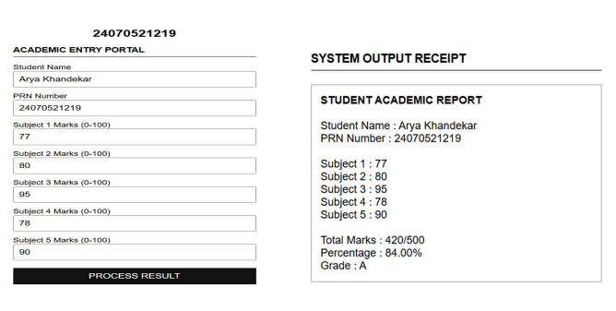
5. OUTPUT :
6. CONCLUSION :
The experiment was successfully implemented using HTML, CSS, and JavaScript. Form validation ensured that only valid student details and marks were accepted, while control structures were effectively used to calculate the total marks, percentage, and assign grades. The grading system demonstrates the practical use of conditional statements and input validation techniques for developing reliable and efficient web applications.

CASE STUDY : 3

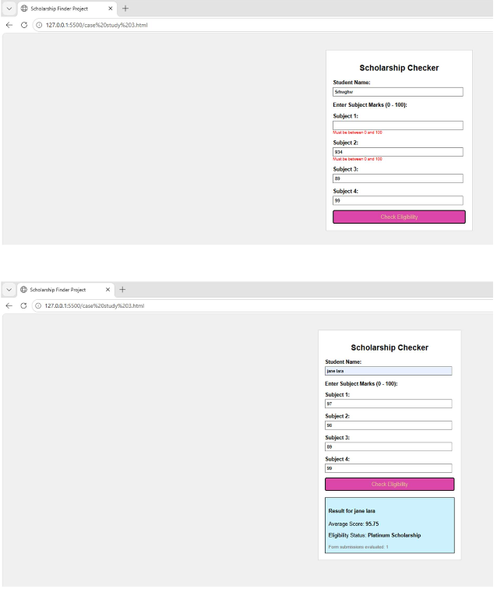

EXPERIMENT NO : 4
- AIM : Use function types, scope, and closures; apply try-catch; build a palindrome checker.

- Software / Tools Used : HTML5 , CSS3, JavaScript, Visual Studio Code (VS Code), Google Chrome / Microsoft Edge Web Browser.

- Theory : JavaScript provides different types of functions such as function declarations, function expressions, and arrow functions. Functions help divide a program into smaller reusable blocks of code.
Scope defines the accessibility of variables in a program. JavaScript mainly has:
- Global Scope: Variables declared outside functions can be accessed
throughout the program.
- Local Scope: Variables declared inside a function can only be accessed within that function.
- Block Scope: Variables declared using let and const inside blocks like loops
or conditions are limited to that block.
A closure is a feature in JavaScript where an inner function remembers and can access variables from its outer function even after the outer function has finished execution. Closures are useful for data privacy and maintaining state. The try-catch statement is used for error handling in JavaScript. The code inside the try block is executed normally, and if an error occurs, the catch block handles the error without stopping the entire program. A palindrome is a word or number that remains the same when reversed. For example, "madam" and "121" are palindromes. A palindrome checker compares the original string with its reversed form to determine whether it is a palindrome.
- CODE :
- <!DOCTYPE html>
- <html lang="en">
- <head>
- <meta charset="UTF-8">
- <title>Palindrome Checker</title>
- <style>
- body {
- font-family: Arial, sans-serif;
- margin: 40px;
- line-height: 1.6;
- }
- h1 {
- font-size: 2em;
- margin-bottom: 20px;
- }
- .info {
- font-size: 1.1em;
- margin-bottom: 15px;
- }
- .input-container {
- margin-top: 20px;
- margin-bottom: 20px;
- }
- input {
- padding: 5px;
- font-size: 1em;
- width: 250px;
- }
- button {
- padding: 5px 15px;
- font-size: 1em;
- cursor: pointer;
- }
- #result {
- font-size: 1.1em;
- margin-top: 15px;
- }
- </style>
- </head>
- <body>

- <h1>Palindrome Checker</h1>

- <!-- Student Information Section -->
- <div class="info">
- Name: Arya Khandekar
- </div>
- <div class="info">
- PRN: 24070521219
- </div>

- <!-- Input Form area -->
- <div class="input-container">
- <input type="text" id="inputText" value="A">
- <button onclick="checkPalindrome()">Check</button>
- </div>

- <!-- Output message text -->
- <div id="result">A is a Palindrome</div>

- <script>
- function checkPalindrome() {
- // 1. Get the text from the input field
- const originalText = document.getElementById("inputText").value;

- // 2. Simple clean up: remove spaces and convert to lowercase for accurate checking
- const cleanText = originalText.replace(/[^A-Za-z0-9]/g, "").toLowerCase();

- // 3. Reverse the clean text
- const reversedText = cleanText.split("").reverse().join("");

- const resultDiv = document.getElementById("result");

- // 4. Handle blank inputs
- if (originalText.trim() === "") {
- resultDiv.innerText = "Please enter some text.";
- return;
- }

- // 5. Check if the original matches the reversed text
- if (cleanText === reversedText) {
- resultDiv.innerText = originalText + " is a Palindrome";
- } else {
- resultDiv.innerText = originalText + " is not a Palindrome";
- }
- }
- </script>

- </body>
- </html>

5. OUTPUT :
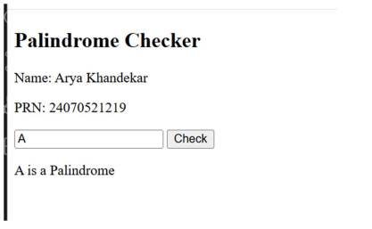
6. CONCLUSION :
In this experiment, we studied JavaScript function types, scope, and closures. We
implemented a palindrome checker using functions and handled possible errors using the try-catch statement. The program demonstrated how functions improve code reusability, how scope controls variable accessibility, and how closures preserve values from outer functions. This experiment helped in understanding important JavaScript concepts used in real-world programming.

CASE STUDY : 4

